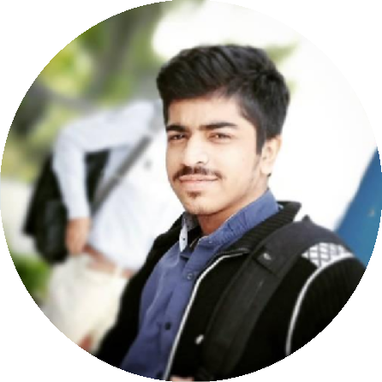



## PROFILE

Software Engineer Interns are entry- level professionals who are gaining hands-on experience in a software development company. Job responsibilities of a Software Engineer Intern are understanding client requirements, writing and testing code, helping to develop software solutions, and updating their job knowledge by using the latest development tools. Based on our collection of resumes in the field, most Software Engineer Interns should hold the following skillset: coding abilities, problem solving, teamwork, the willingness to learn new things and to follow instructions, and computer proficiency. Successful example resumes make display of a Bachelor's Degree in computer science or information technology.

## CONTACT

PHONE:

0345-2849128

WEBSITE:

http://my-portfolio0001.infinityfreeapp.com/

EMAIL:

[Fahad.yahya18@gmail.com](mailto:Fahad.yahya18@gmail.com)

## HOBBIES

Travelling Cycling

Capturing happy memories

# Software Engineering

## EDUCATION

### Muhammad Ali Jinnah University 2019 - Continue now

**Bachelor of Software (BSSE)** Software Engineering

Affiliated with **Higher Education Commission (HEC),**Pakistan

### Nabi Bag Government College 2017 - 2019

**Intermediate (HSC)** Pre - Engineering

Affiliated with **Board of Intermediate Education Karachi (BIEK)**, Pakistan

### Nobile Grammar School 2016

**Matriculation (SSC)** Science Group

Affiliated with **Board of Secondary Education(BSEK),** Pakistan

## WORK EXPERIENCE

### SELECTIONS HOME Developer

Sep 2019 – Till to day

Complete Web site Build Up, Installation of Extensions Like Email /Themes, Update Product /Category, Update Picture With Tag, Daily Backup, Daily Changes Like Product /Image /Tag & Email System Configure (Like Order, Inquiry Etc.)

|  |  |
| --- | --- |
| **SKILLS** |  |
| React | 75% |
| React native | 75% |
| Java | 65% |
| C language | 100% |
| Html, CSS & JavaScript | 100% |



# Software Engineering



## PROJECT ACCOMPLISHED

### Laser Engraver Robot |

### DIY Arduino based Project

### [Click here more details](https://www.linkedin.com/posts/muhammad-fahad-3953711b0_construction-flutterdeveloper-flutter-activity-6938811980874952704-lIsD?utm_source=linkedin_share&utm_medium=member_desktop_web).

### Online Examination Management System Java Project (2nd Semester Project).

Management system, regarding Quiz app

Technology Used: Java, Javafx, SQL, PHP & Adobe illustrator

[Click here more details](https://github.com/MFY2000/Examination-Portal).

### Website (Vinegar-Foods) (1nd Semester Project).

A Dynamic Website for an Online Food Order.

Technology Used: HTML5, CSS3, JavaScript, Firebase database & Adobe illustrator

[Click here more details](https://github.com/MFY2000/Vingar-Food-s).

### School Management System-Assignment/Task

Technology used; Netbeans 8.0, Jasper report 4.7 and Adobe Photoshop

### Library Management System-Assignment/Task

Technology used; Netbeans 8.0, Jasper report 4.7 and Adobe Photoshop



## CONTACT

PHONE:

0332-2520302

WEBSITE:

https://web-and-mobile-hybrid-ap- a0680.web.app/

EMAIL:

[Fahad.yahya18@gmail.com](mailto:Fahad.yahya18@gmail.com)

## HOBBIES

### Event Management System-Assignment/Task

Technology used; Netbeans 8.0, Jasper report 4.7 and Adobe Photoshop

### Hospital Management System-Assignment/Task

Technology used; Netbeans 8.0, Jasper report 4.7 and Adobe Photoshop

### Utility Management System. Assignment/Task,

Technology used, c Sharp. Visual Studio, Adobe Photoshop, My SQL.

### Go Commerce App. Assignment/Task,

React native Project regarding E-commerce App

Technology used, c Sharp. Visual Studio, Adobe Photoshop, My SQL.



# Software Engineering

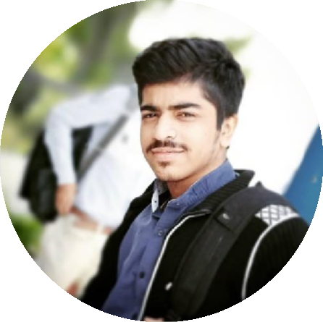

## IT SKILLS

|  |  |  |
| --- | --- | --- |
| **Languages:**   * Html5 * CSS3 * JavaScript * Java * C language * Python * Php * Magento | **Editors:**   * VS code * Sublime * Android Studio * IntelliJ idea * PyCharm * Dreamweaver * NetBeans | **Databases:**   * Sql Server * NodeJs * MongoDB * Firebase database |



## CONTACT

PHONE:

0332-2520302

WEBSITE:

https://web-and-mobile-hybrid-ap- a0680.web.app/

EMAIL:

[Fahad.yahya18@gmail.com](mailto:Fahad.yahya18@gmail.com)

## HOBBIES

Travelling Cycling

Capturing happy memories